Step 1: Create project and Initiate git repository. (git init)
- Create a new workspace and create a Java project on it
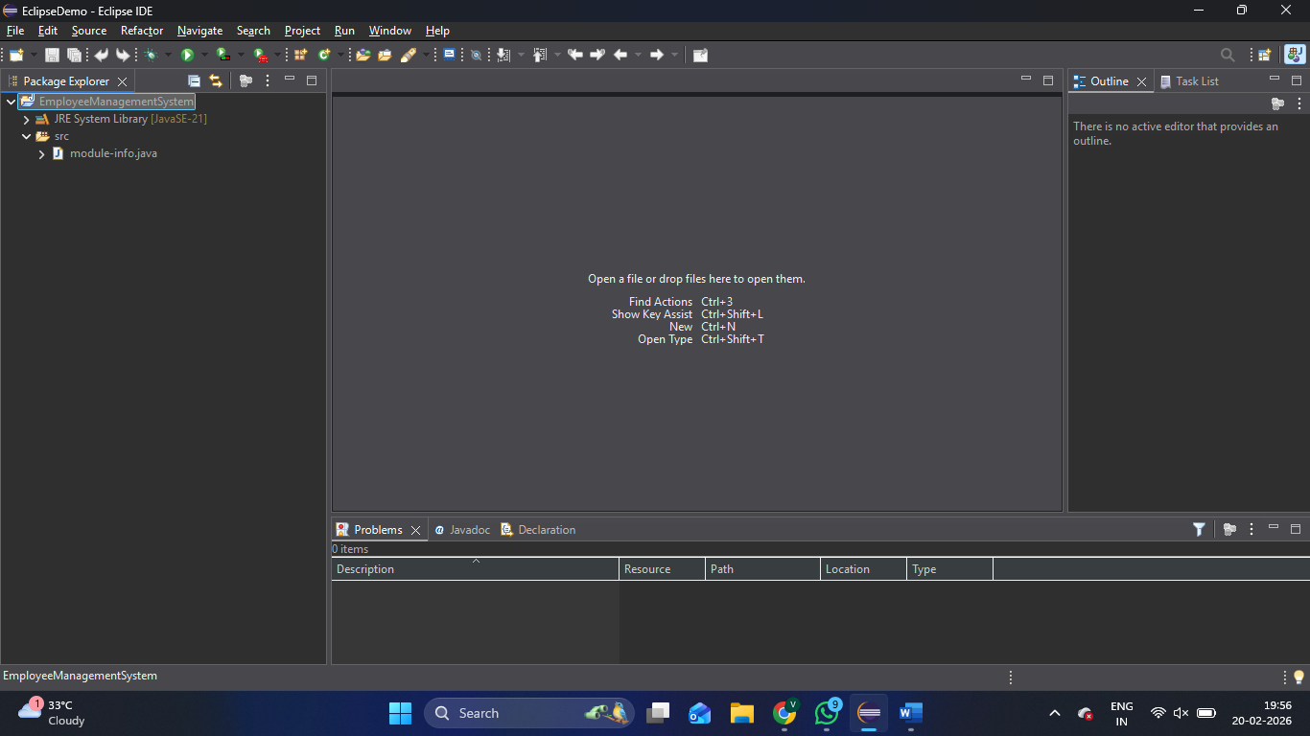

- In GitHub, create a new repository.
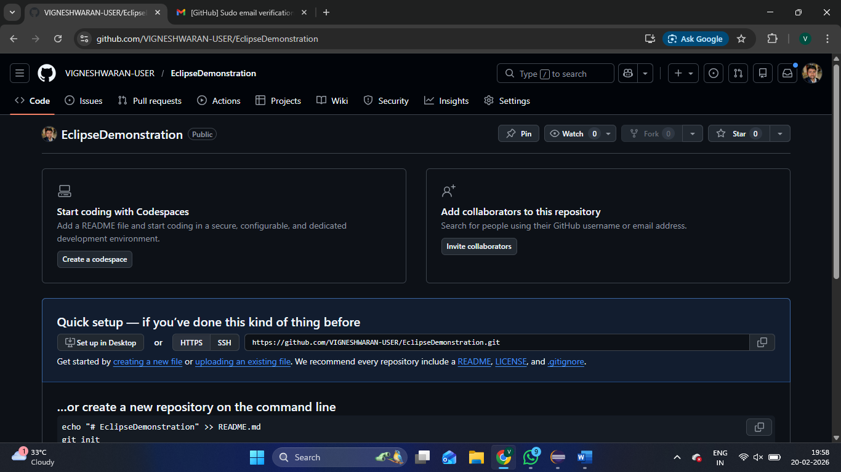

- In Eclipse right click on the project and click team and give share project, then in the repository field click create.
- In the new pop-up window, set the path for the directory and default branch name (master à main) and click Finish
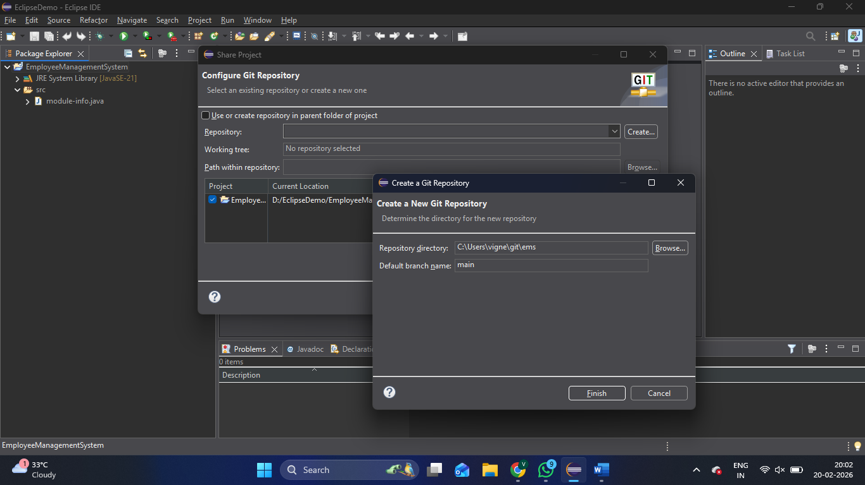

- In the git repositories tab, you can find your project now.
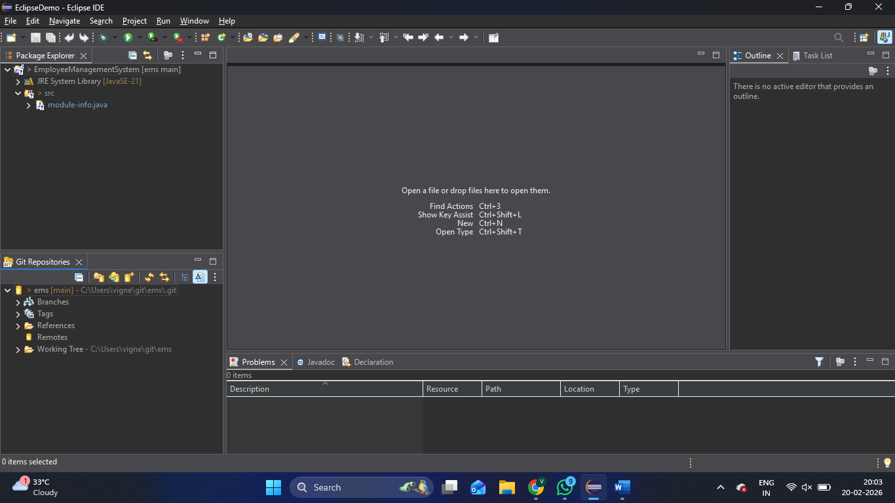

The above steps are equivalent to git init command.
Step 2: Stage the untracked files. (git add .)
- Again, go to Team, now you can find Add to Index option. Click that to stage the files.
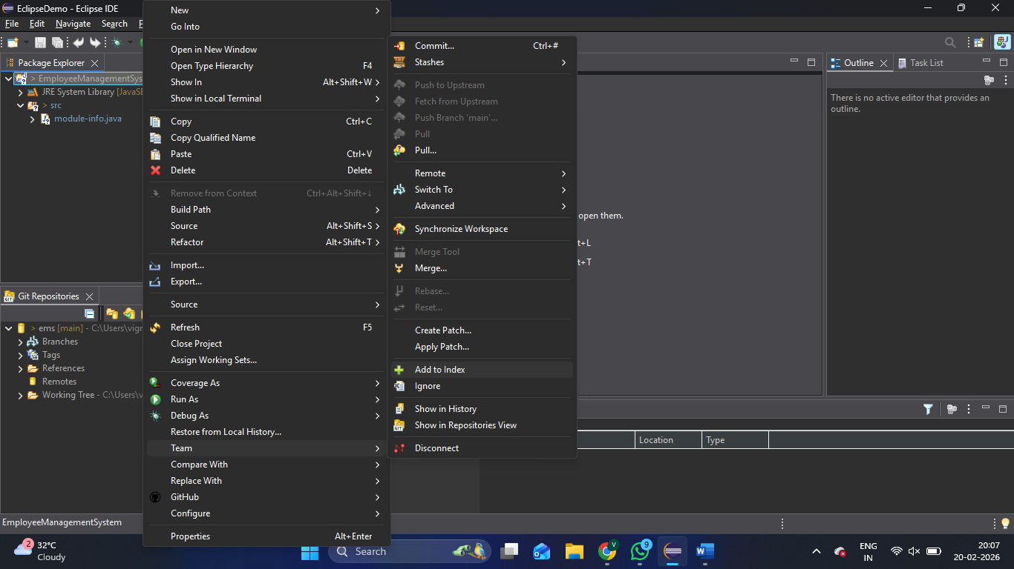

Step 3: Commit changes to the local repository. (git commit -m “first commit”).
- Again, go to Team, now you can find Commit option. Click that to open the commit window.
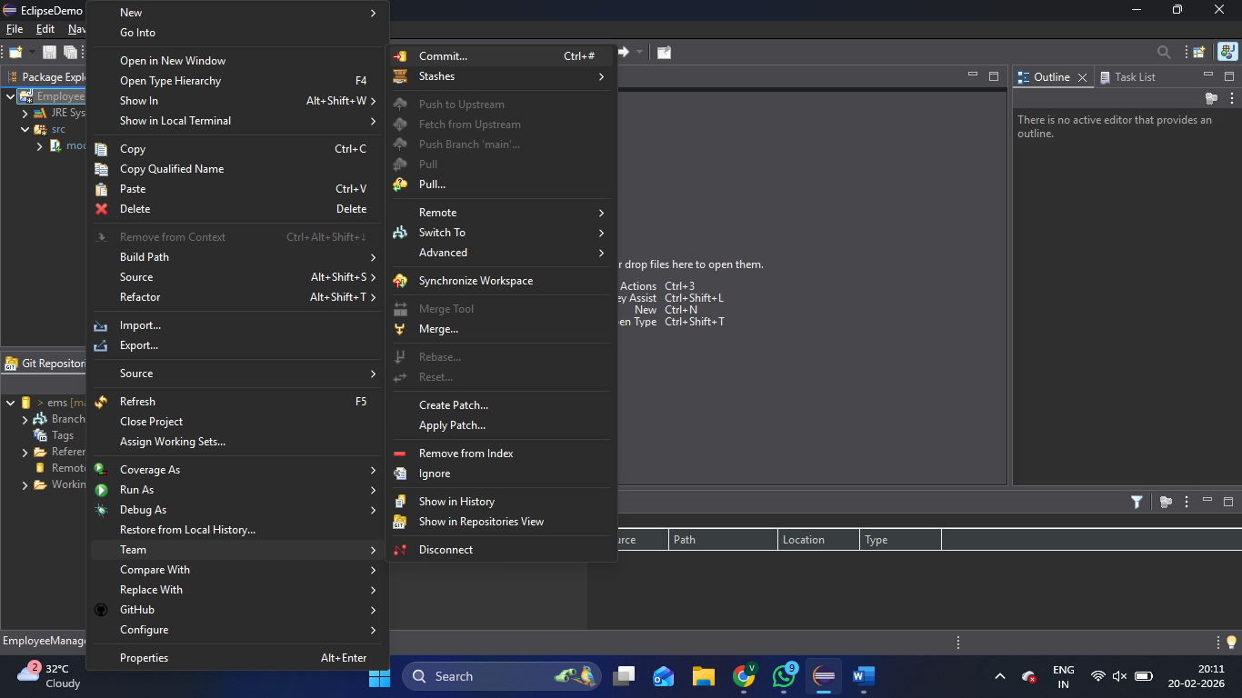
- Check the files are staged and give commit command and hit commit button
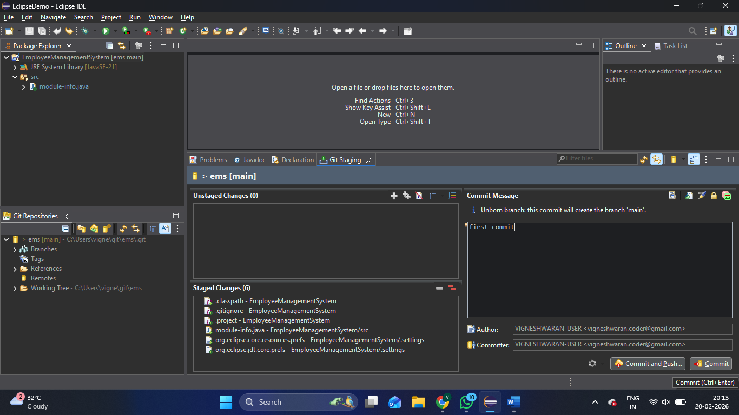

- In the local branch you can check the commit
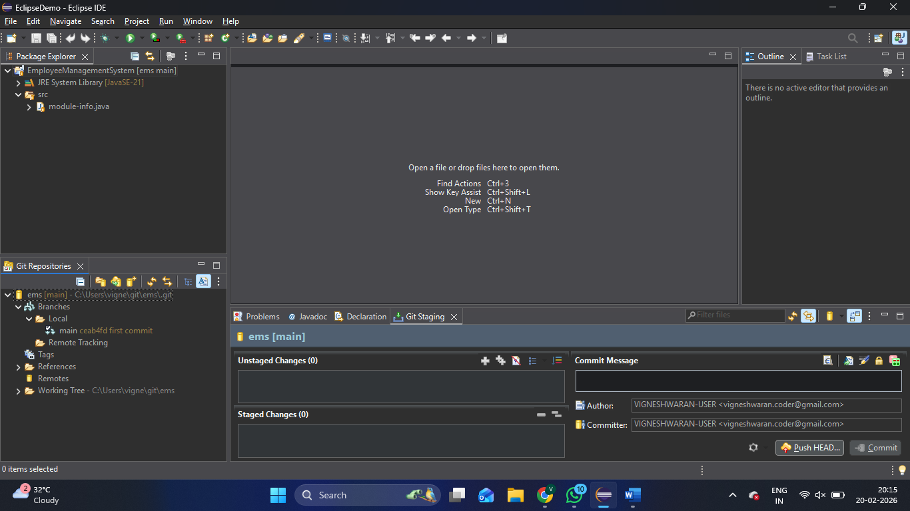

Step 4: Push the code to GitHub Repository (git push origin main).
- Again, go to Team, now you can find Push Branch ‘main option. Click that to open the Destination setup window.
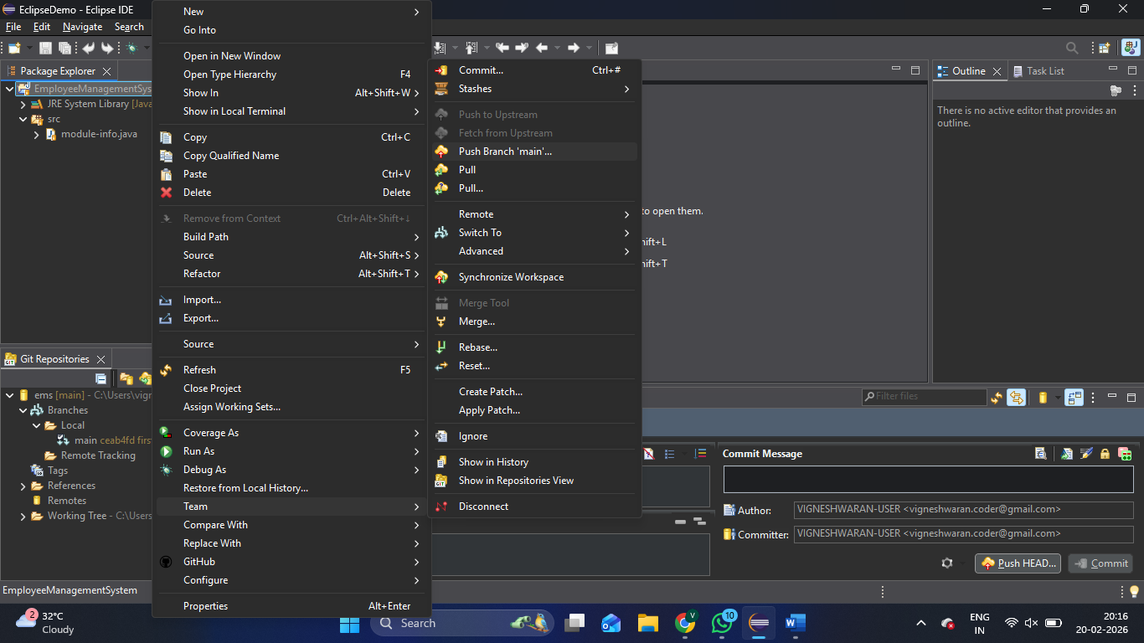

- Paste the GitHub URL, username and password, then click preview and then push button
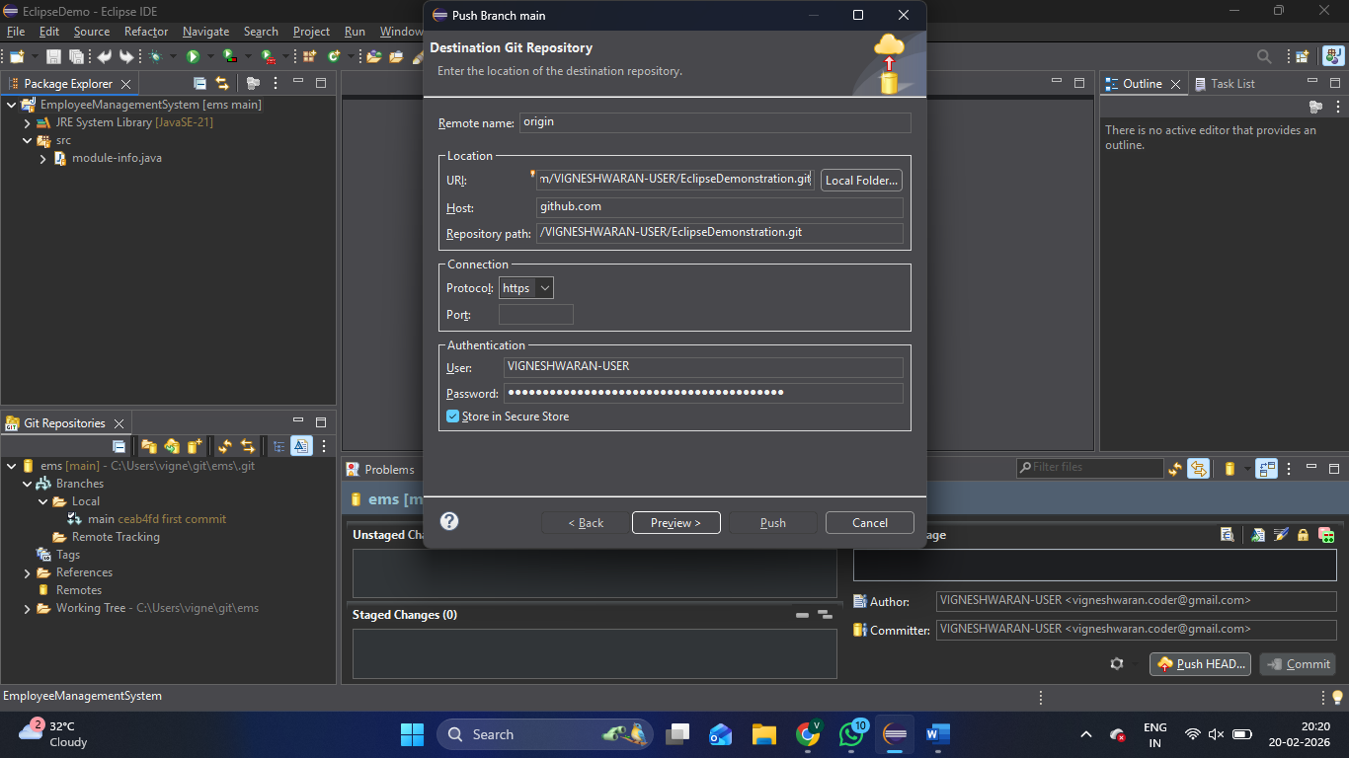

- The project will be added to the GitHub repository.
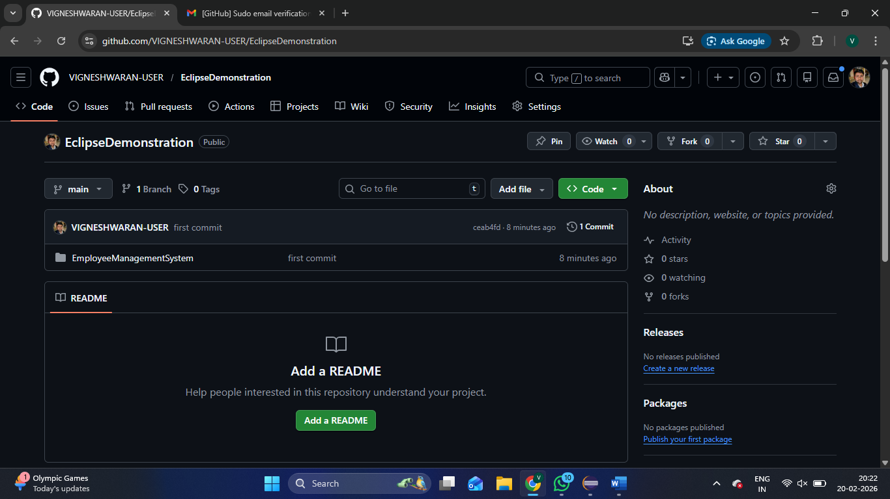

Step 5: Create a new branch (git branch Vignesh / git checkout Vignesh).
- Go to Team, Click Switch To, Click New Branch.
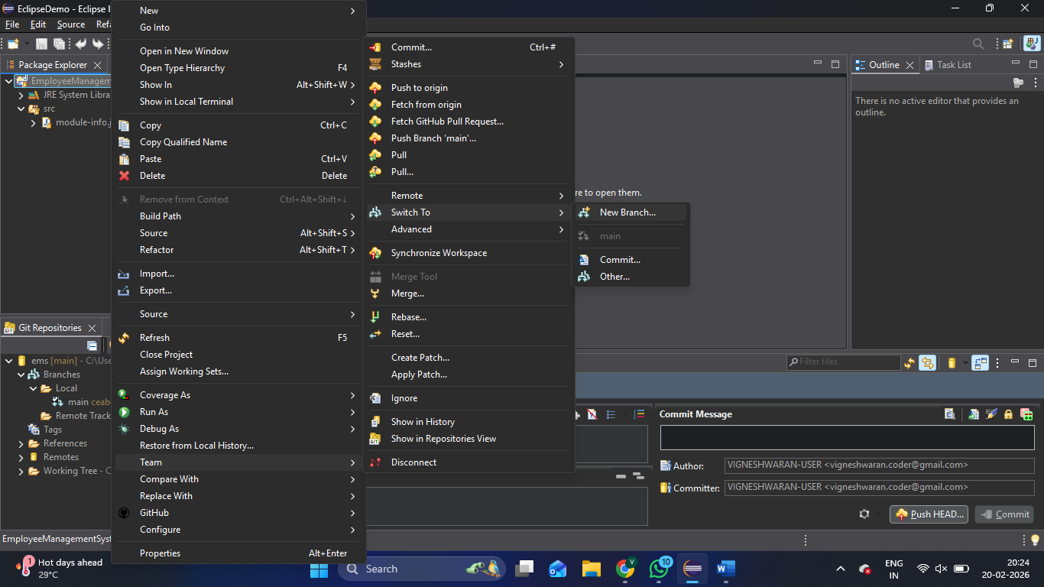

- In the pop-up window, give the branch name and hit Finish.

- You can check the branch in git repositories. Now the branch is created locally, now you can make changes in the code.
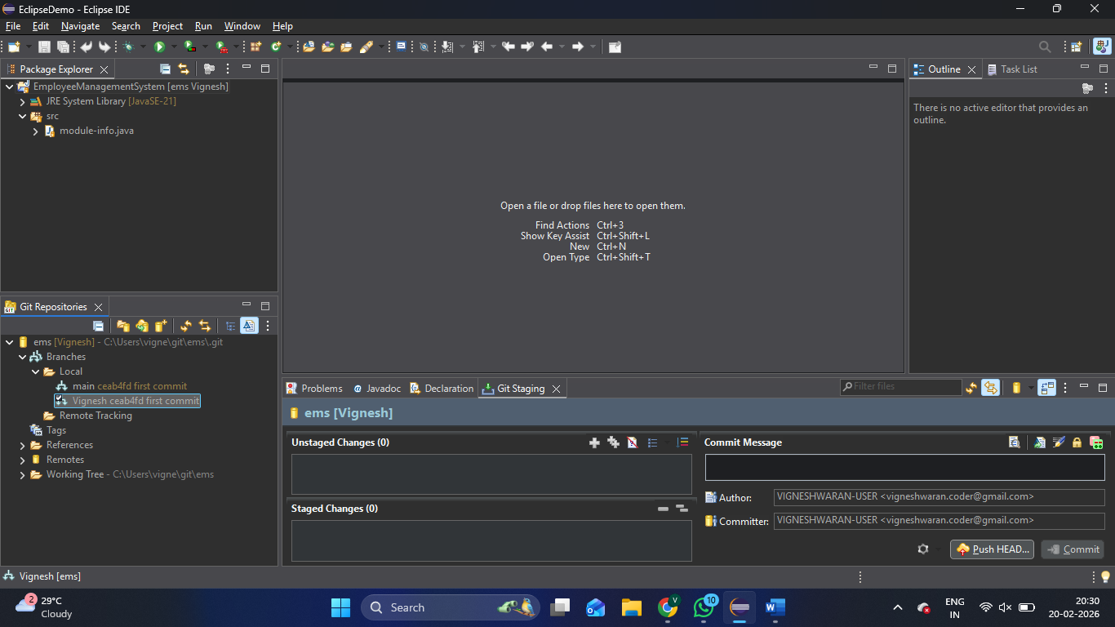

Step 5: Push the branch to the GitHub (git push origin Vignesh).
- Now you are on your own branch, you can make changes in your code, and that will be added to your branch. Then you can add that changes into index and commit the changes like we saw in the previous steps.
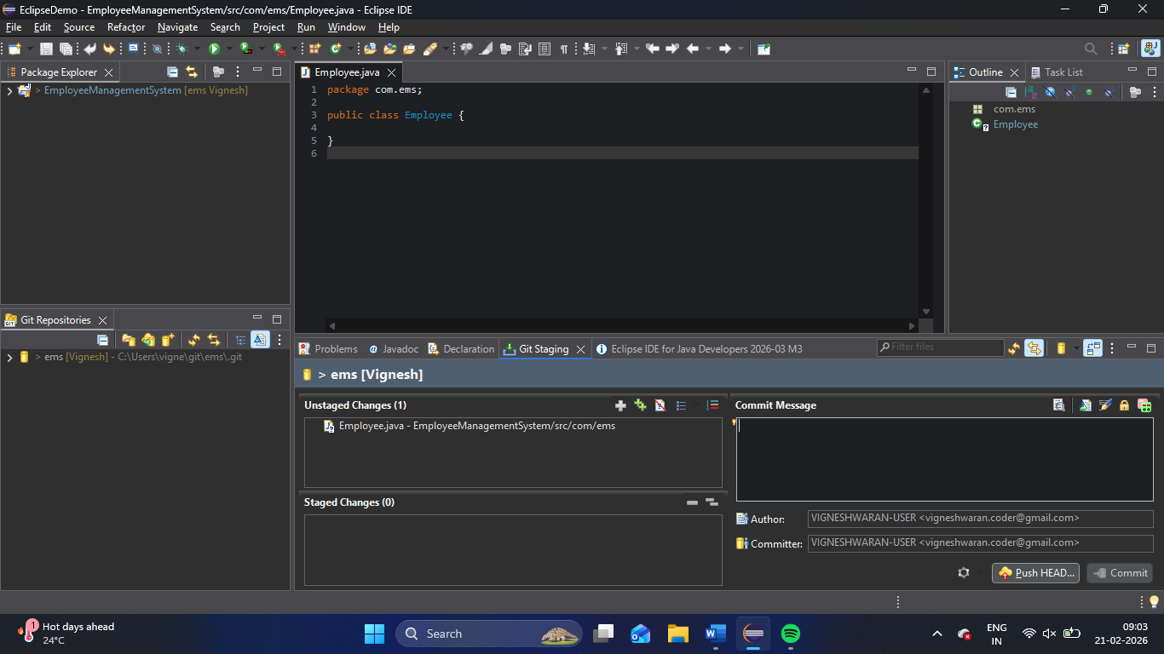
Here you can see that I have created a file and its on Unstaged changes in Git Staging page. Now I need to make it staged and commit with a message, “Commit from Vignesh branch”.
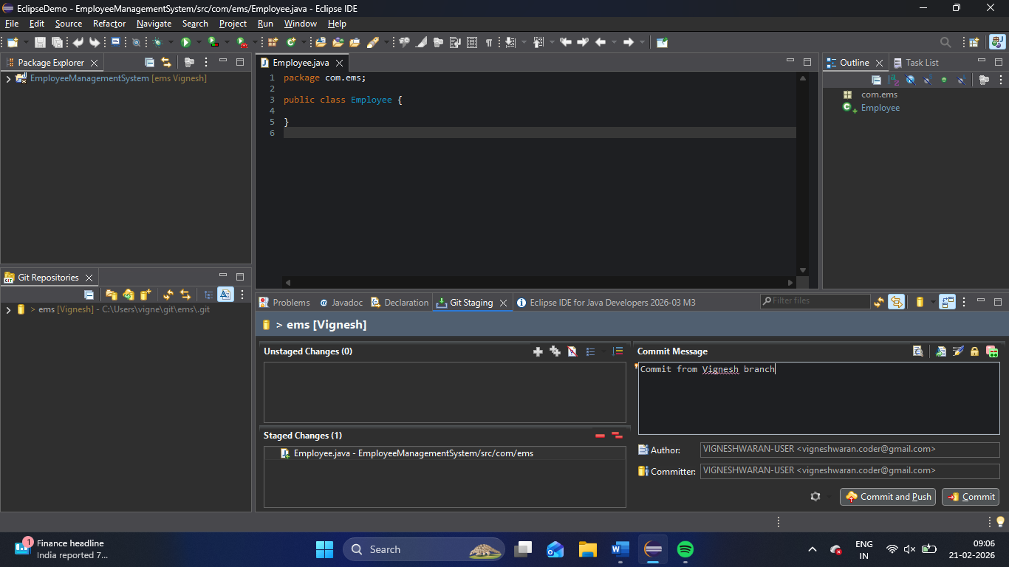

And you can hit commit here.

- Now you need to push the commit to the GitHub, for that, go to Team, click Push Brach ‘Vignesh’
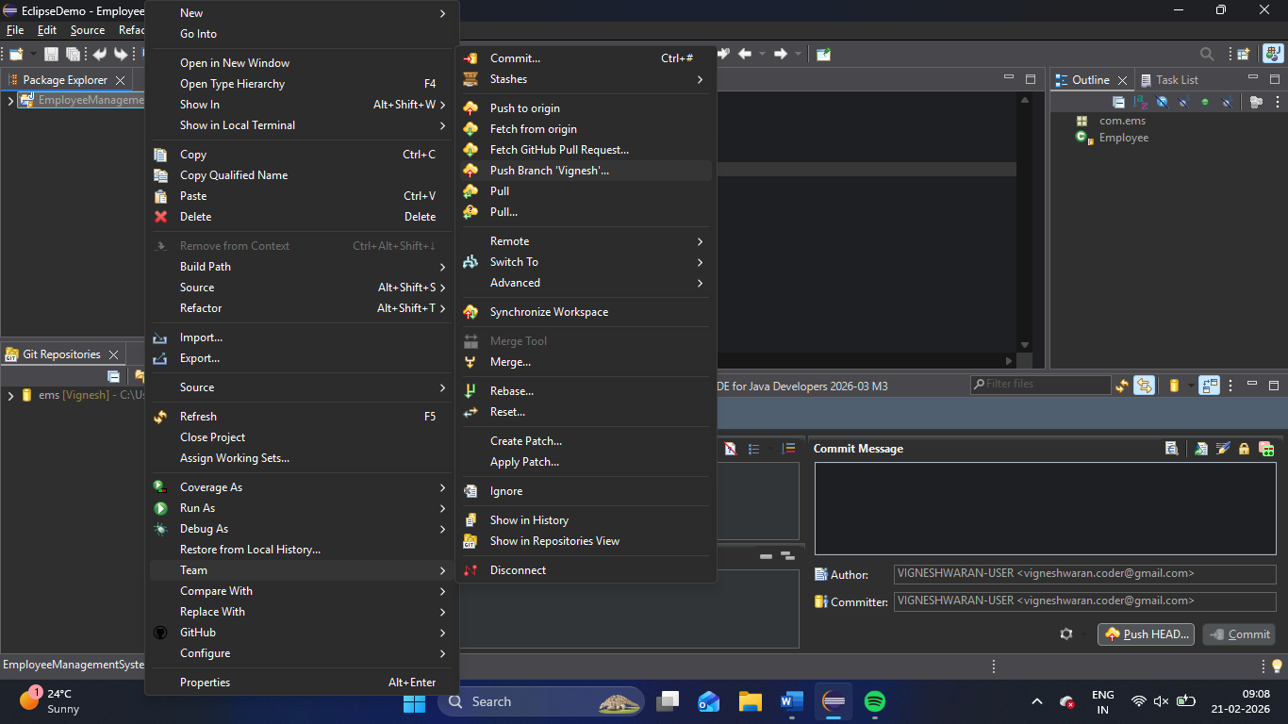
- In the pop-up window, click Push.
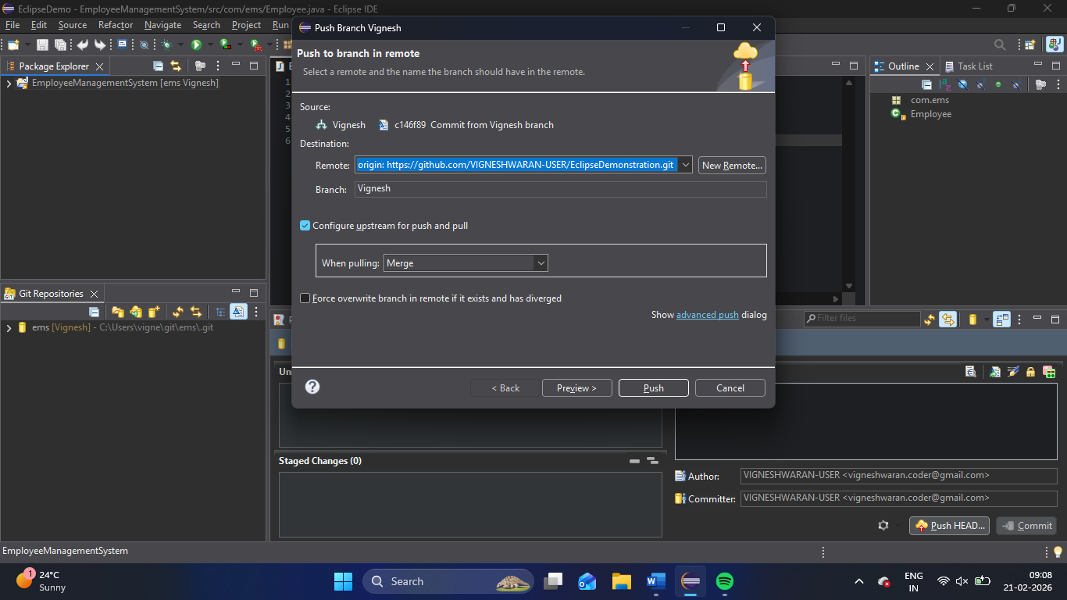

- In GitHub, you can see the branch with the commit message.
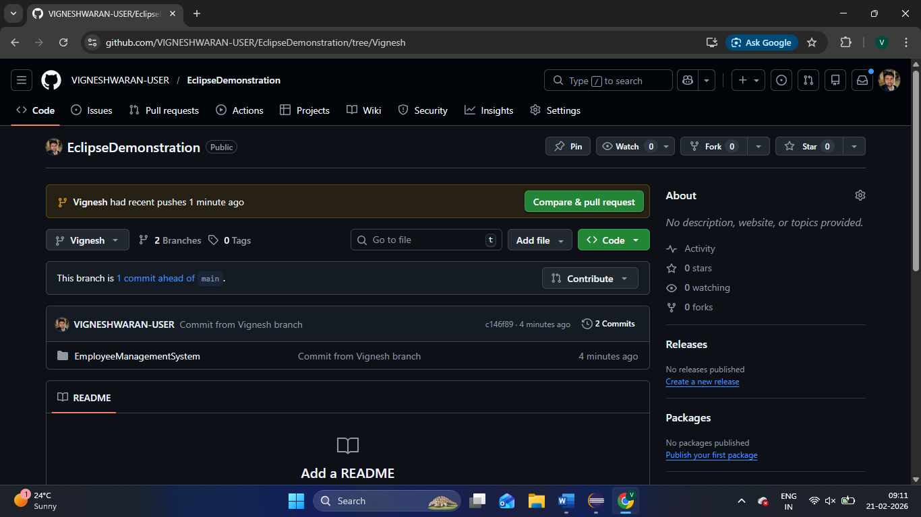

Step 6: Merge the code from Vignesh to main branch
(git checkout main | git merge Vignesh | git push origin main).
- Go to Teams, Click Switch to, Click main.
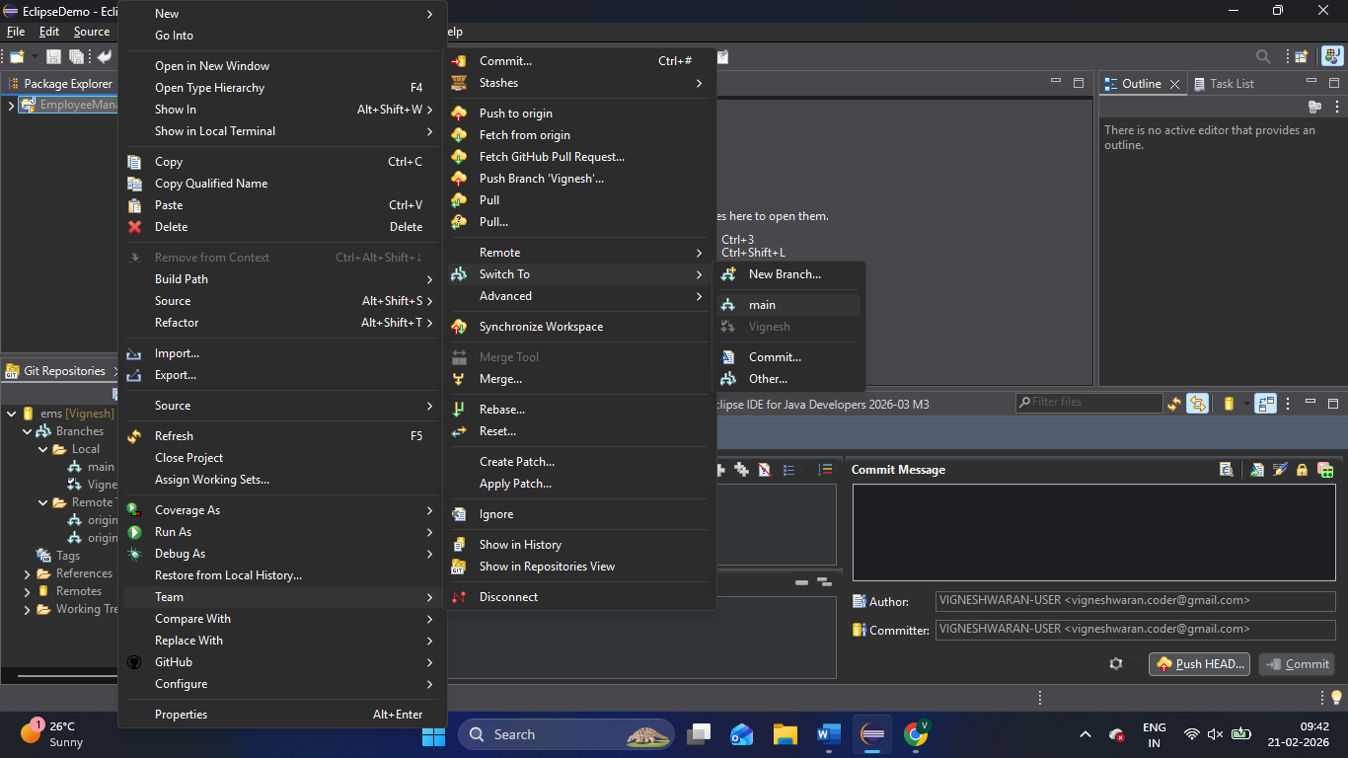

- Again, go to Teams, Click Merge, Click main, the merge window will appear. There you can select the branch you want to merge and click Merge.
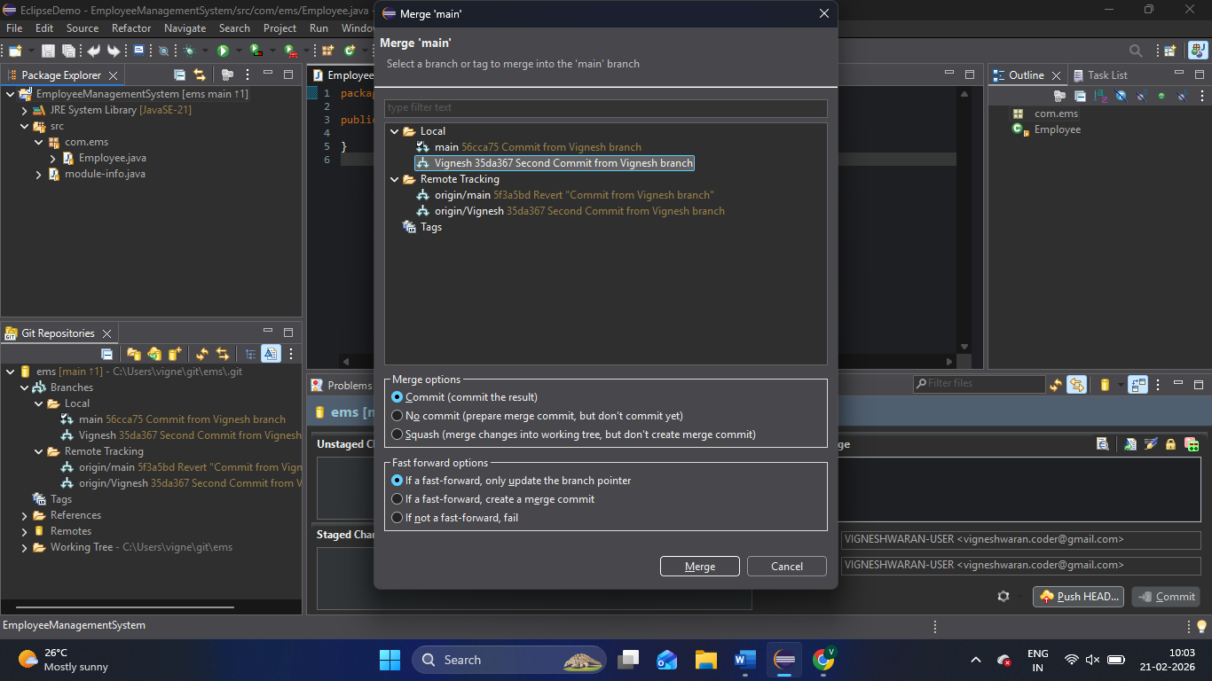

- Now as usual we can push the main branch in Team, and we can see the updated main branch in GitHub.

How to clone the Repository? (git clone <remote name>)
For this, I am using another account, and I will clone the same repository.
- In the git repository window, you can find the clone repository option.
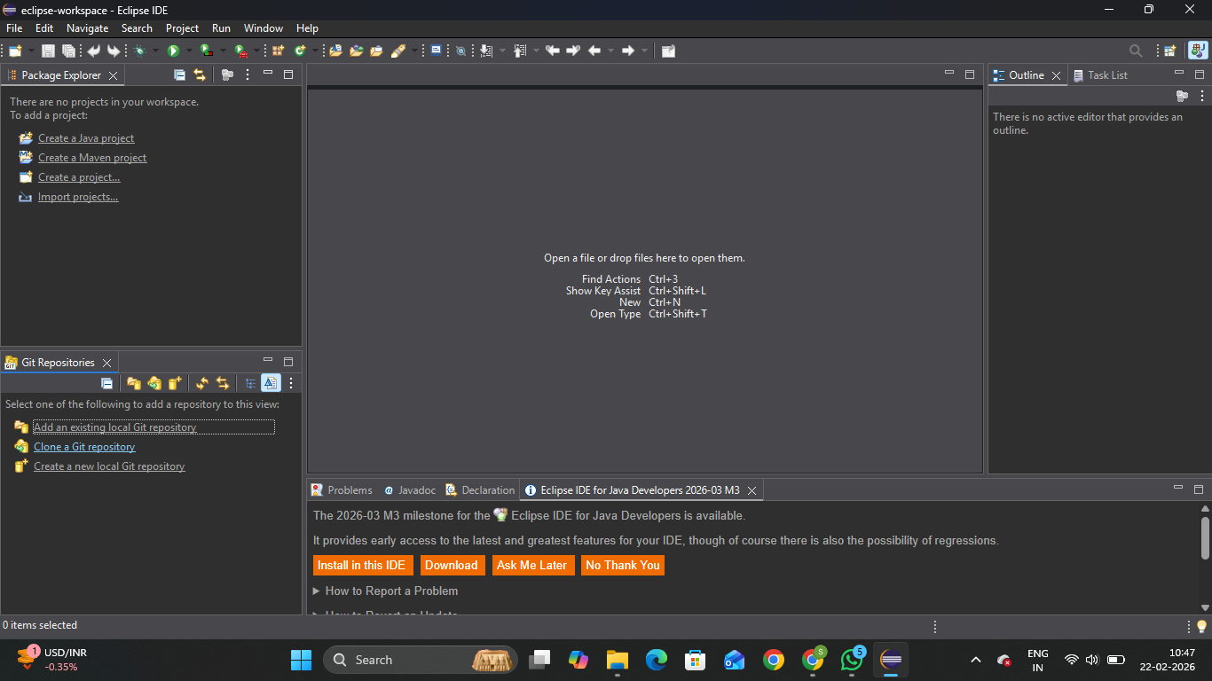
- In that, select Clone URI, and enter the credentials and click next
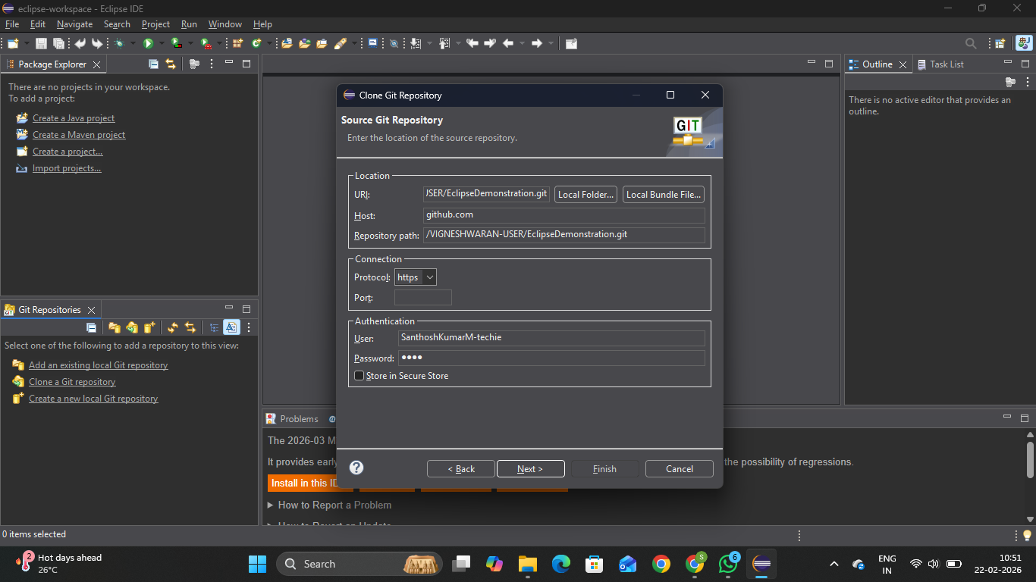
- Select the branches to clone and click next.
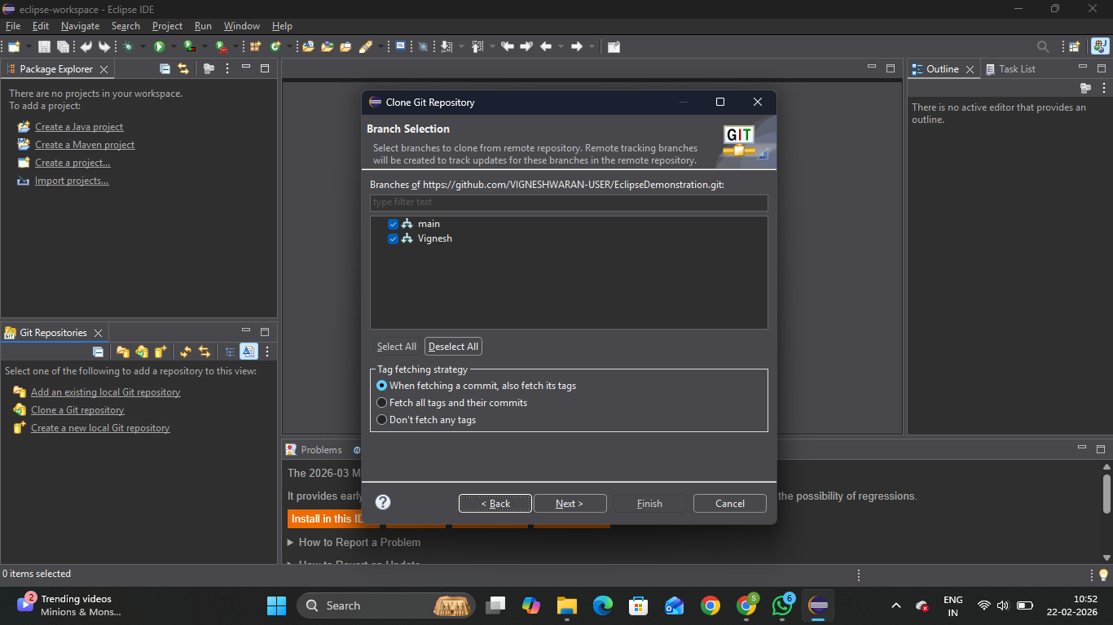
- Set the directory and click Finish
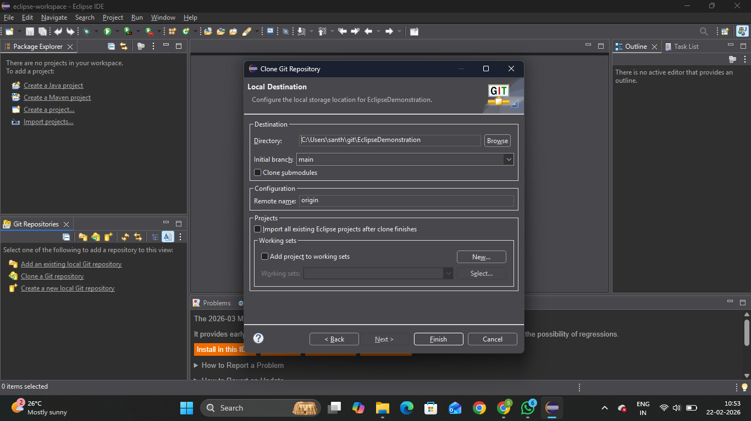
5. You can find the project in git repository and now you can import the project.
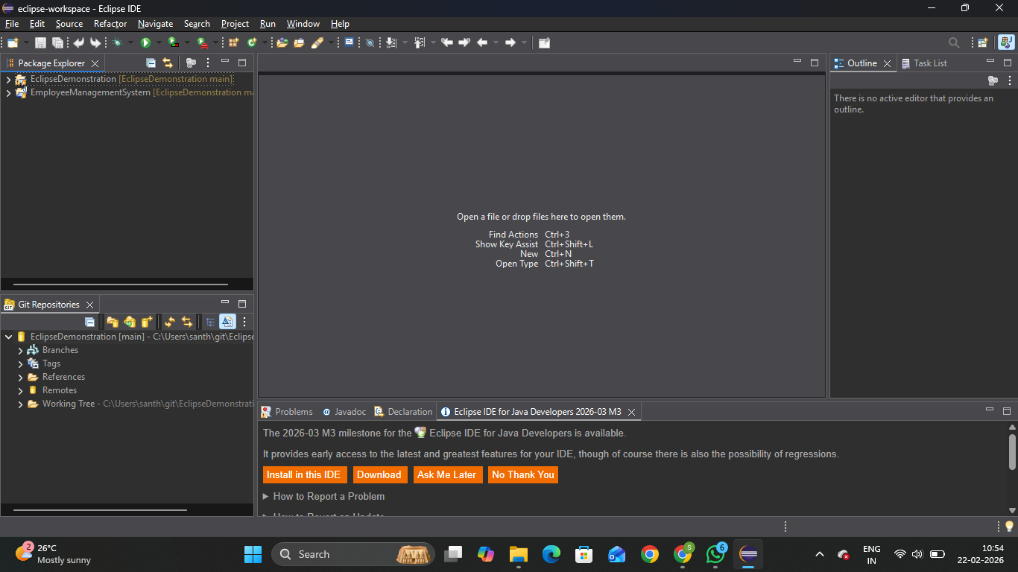
How to pull the code before we pushing to the repository and how to resolve conflicts? (git pull).
As of now, the branch is cloned by team member, he created a new branch and working on it and in the meantime Vignesh is pushed the update and merged to the main branch. When the team member tries to push his update, he will be instructed to pull the code first and then push.
- The update is pushed to the github main branch by Vignesh.
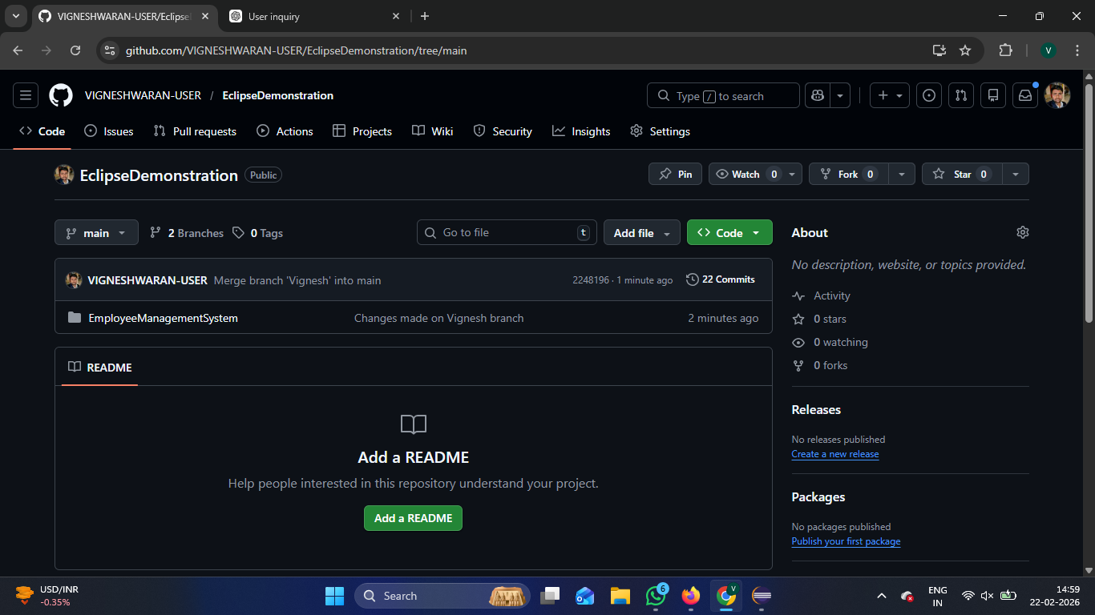
- When I try to made changes and push the code, my push action will get rejected. Which means my branch is behind.
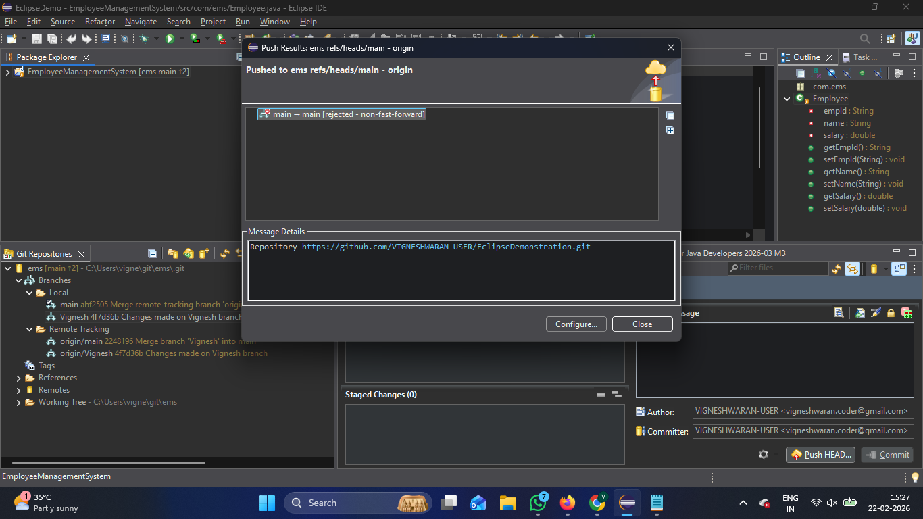
- So, I need to pull first, for that I can go to team and give Pull option, the code will be pushed.
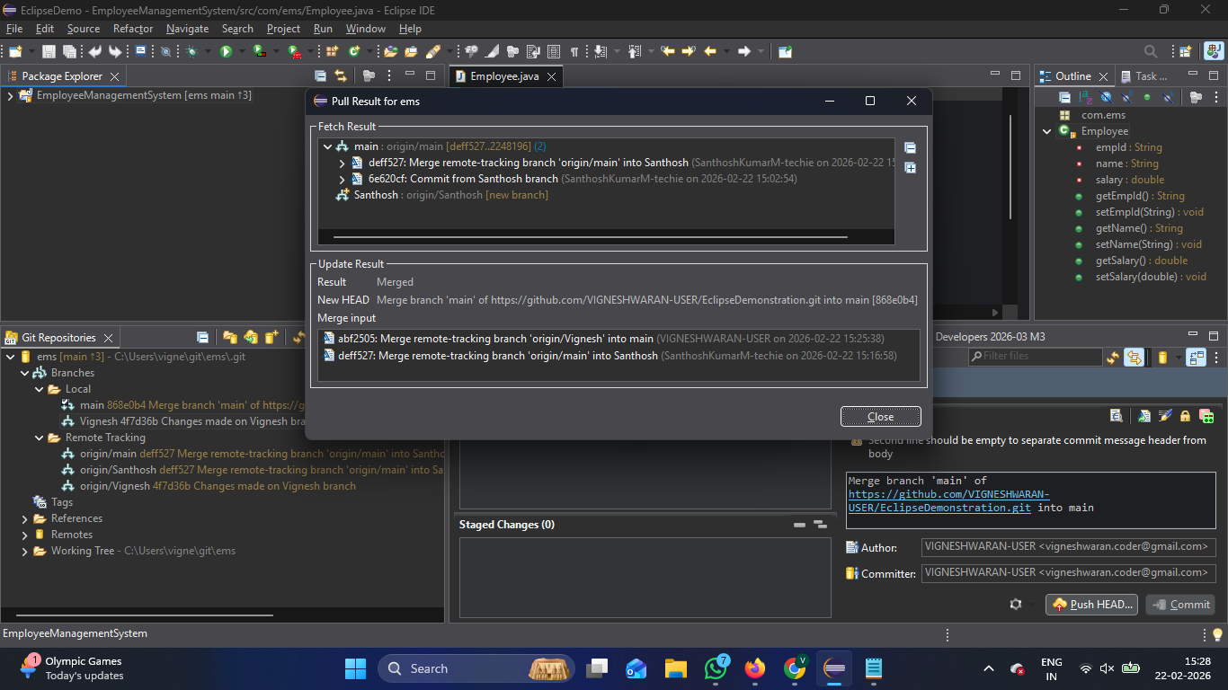

- Suppose if there is a conflict it will be reflected like the below, then we can resolve, commit and push it again.
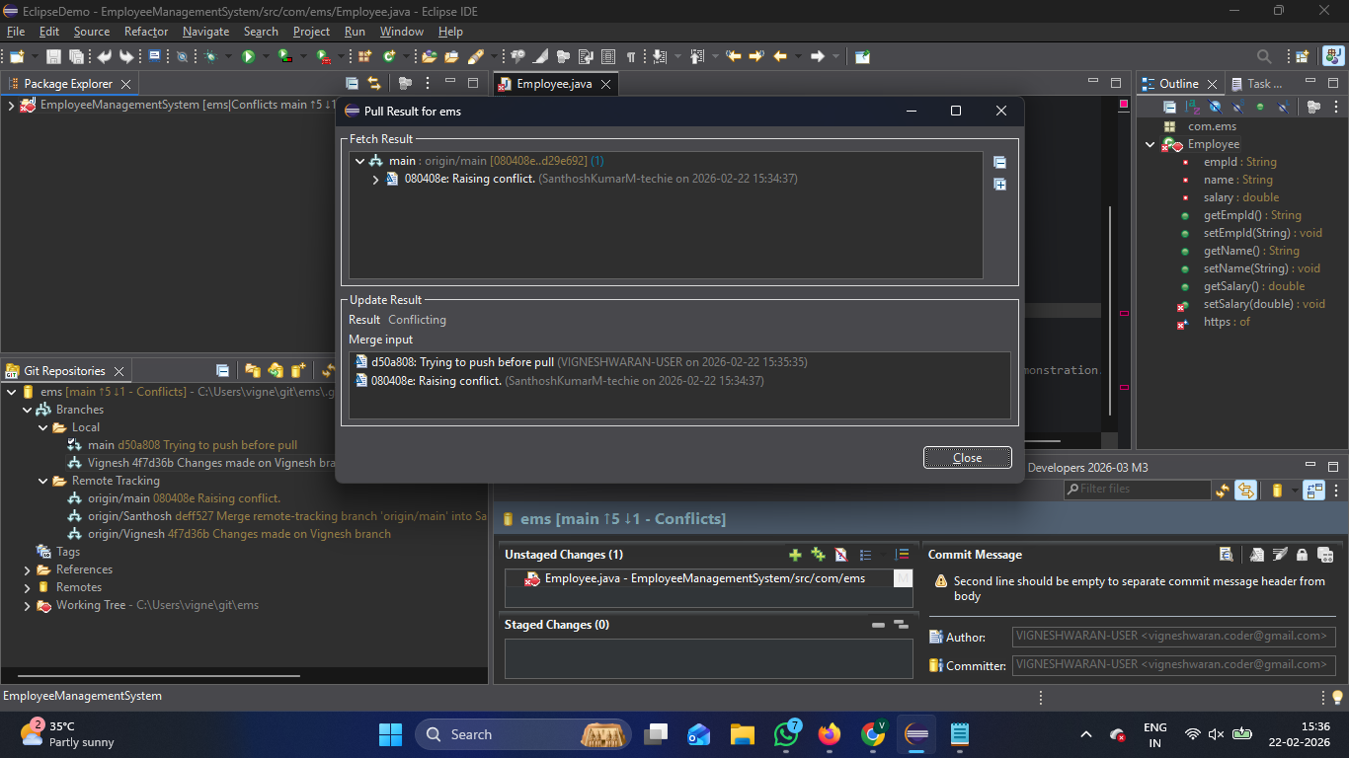
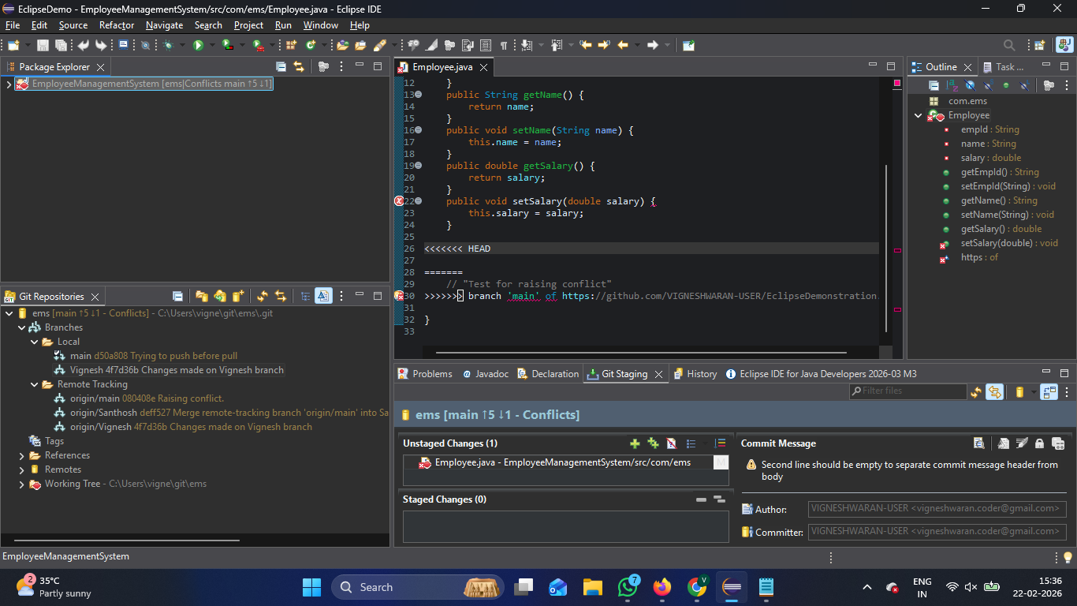
This is how we want to resolve the conflict in eclipse.

